**Subject:** Your temp. measurement requirements for New Highest Performing Portable Handheld infrared thermometer by Process Sensors IR.

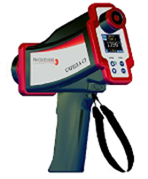

**Revolutionizing the portable IR thermometer market**, Process Sensors is proud to offer the next generation of versatile, precision portable infrared thermometers with unrivaled features and functionality for measurement, display and pinpoint accuracy. Delivering **ultra-high accuracy**, high speed (1 millisecond), precision manually focusable optics, **bright green laser targeting light** visible on hot glowing targets and small spot sizes, the five model Capella C3 Series, are all contained within a **rugged cast metal housing** that will stand up to the rigors of harsh plant conditions and perform flawlessly.

The Capella C3 Series gives an operator the option to customize the values on the large display.  Through lens sighting and laser targeting light, **1-color or 2-color operation**, manually focusable optics, switchable serial interface, two display formats, several operating modes – all can be selected quickly and directly on the 2.6 pound handheld IR thermometer.

This dynamic new series of handheld thermometers for measurement in the short-wave spectral range is perfect for metals, induction heating, semiconductor wafers, susceptor and molten silicon, furnace refractory, molten glass, welding, graphite, ceramics and medical applications

Several operating modes can be selected depending on the operator’s needs – a display mode with no data storage, an auto save mode triggered by one touch of a button, continuous measurement mode with data storage in < 1 ms, and an interval mode with definable measuring and pause times. A Li-on Battery provides operation for longer than 8 hours of continuous use.

The 1- and 2-color Capella models boast a wide temperature range of 180° to 3300°C (356° to 5972°F) and response time of less than 1 ms.  There are two bright, backlit OLED display modes to choose from, very sturdy aluminum cast body with rubber housing bumpers for protection and a tripod mounting thread for stationary hands-free operation.  All device parameters are adjustable via 4 buttons and measurement parameters can be changed directly from the display without a menu call up. Data storage is simplified allowing access to up to

32,000 measured values including date, time, measuring parameters and measuring location designations.  Serial interface is switchable to USB 2.0 for charging and data readout.

Process Sensors Corporation offers the widest range of high performance, non-contact infrared temperature sensors, thermal imaging / thermal line scanning systems, and blackbody calibration sources to meet the most demanding on-line industrial process, laboratory and R&D application requirements.

Detailed specification information can be found at [www.processSensorsIR.com](http://www.processSensorsIR.com).

Best Regards,

Scott Nagle

Division Manager / Application Specialist

Process Sensors - IR Temperature Measurement Expert

787 Susquehanna Ave

Franklin Lakes, N.J. 07417

Tel: 774-399-0461

Cell: 508-344-5420

Email:snagle@kpmanalytics.com

[www.processSensorsIR.com](http://www.processSensorsIR.com)

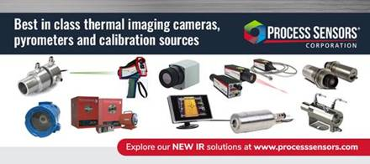

***a KPM Analytics company***