

Process Sensors IR “Infra-Boiler” System:
For Hot CO₂ Gas or Flame Temperatures
in The Power Generation Industry

Introduction
There exists the demand for a high degree of accuracy in measuring and controlling the temperature of flue-gas in power generation plants that must be maintained within a very narrow range as directed by EPA standards, while still assuring the energy efficiency and production of steam within the boiler and safety of the plant. Conventional contact-type thermocouples come up short when compared to the reliability and accuracy displayed by carefully specified non-contact infrared temperature sensors. Use of thermocouples limits the area being measured to the boiler wall surface location rather than the centermost points of the boiler where the temperature is significantly higher. Also, coal fired boilers typically tend to accumulate soot and ash deposits, insulating the thermocouples, thus falsely indicating lower temperature measurement readings inside the boiler or incinerator. Both circumstances are less than desirable as they produce lower than actual temperatures and can lead to refractory and boiler tube damage. Ideally, a balance must be struck that allows the most favorable system performance while still safeguarding all the related components against damage or destruction. A remote sensing infrared detection system that operates in the mid four-micron wavelength, CO₂ Gas absorption band region, offers such a solution.
Boiler Design and the Need for Monitoring
Boiler design involves the energy balance between fireside and steam-side parameters. Typically there tends to be more steam-side instrumentation designed and fitted in a boiler control system than there is fireside instrumentation, but since the fireside generates the heat transmitted to the boiler system it is essential to control its operation as well. The lack of fireside control means that air and fuel mix and combust in the burner system and go unmonitored through the flue gas path until exiting the boiler. Clearly, temperature monitoring is needed at a point between the burner and the boiler exit. The solution is the addition of another control point or furnace exit gas temperature check point between the two. The additional control point will make an enormous difference in the overall performance, endurance and reliability of the boiler as it alerts operating personnel to possible trouble situations well before they occur and cause irreparable damage or unnecessary wear and tear.
While the addition of a furnace exit gas temperature check point is essential, its operation can only be considered successful if it achieves maximum penetration into the gas combustion stream. Generally, high temperatures and greater concentrations of combustion by-products or particulates in the flue gas stream reduce the IR sensing depth of measurement capability into the gas. At some distance, there is an extinguished depth of penetration where a pyrometer cannot “see” any further as the detector becomes saturated. Use of a highly stable non-contact infrared pyrometer that functions in the mid four-micron wavelength, CO₂ Gas absorption band, enables an operator to site through the cooler gases that skirt the boiler perimeter and zero in on the measurement within the gas stream that is more representative of the true actual temperature.
Some Benefits Achieved by CO₂ Gas and Flame Temperature Monitoring
- The correct monitoring system will trigger a FEGT (furnace exit gas temperature) alarm when the highest temperature and maximum load condition for efficient operation is reached, thus preventing boiler waterwall, reheat and superheat tube failure.

- During boiler start-up it is essential to confirm that there is steam flow through the boiler tubes before exceeding a lower critical temperature limit. This ability may prevent fracture of temporarily non-flowing boiler tubes if all required operating procedures are met.

- For incinerator applications, in addition to trimming burners, a minimum acceptable operating temperature can be monitored to meet or exceed environmental requirements.

- In coal burning operations, an upper temperature limit can be monitored to reduce fusion related maintenance and down-time.

- When used with an on-line utility boiler, the precise temperature readings can be used to trim burners and balance boiler temperature, thereby reducing excessive fuel consumption as the hour to hour demand for power reduces.

- In Selective Non-catalytic Reduction Systems, the system can sense temperature “window” set points for the injection of low nitrogen oxide enhancers with urea or ammonia.

- The pyrometer system replaces high-maintenance thermocouples with reliable, precision, low-maintenance sensors in rugged protective housings.

- The IR temperature system monitors flue gas temperature ramp for startup preventing over-firing that could damage superheat tubes, or under-firing that could send damaging wet steam to the steam turbine buckets.

- The correct IR sensor system reduces slagging and ash fusion by monitoring the maximum allowable temperature in the boiler superheat/reheat section for ash fusion alarm points.

- Boiler gas temperature can be monitored for comparison to steam outlet temperature readings to determine the need for soot blower activation.

- Flue gas temperatures in separate sections of boilers with division walls can be monitored to achieve temperature balance.



Process Sensors IR “Infra-Boiler” Pyrometer System
For Hot CO₂ Gas Temperatures in The Power Generation Industry

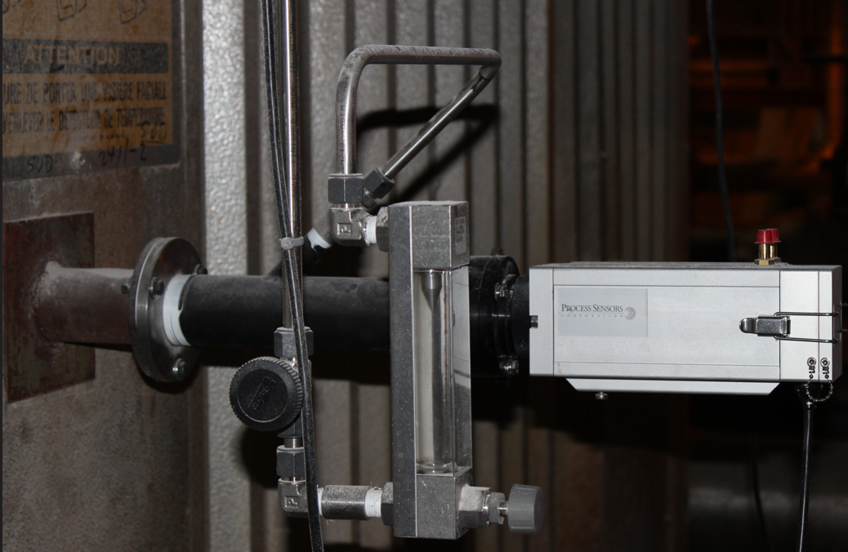

The PSC “Infra-Boiler” Non-Contact Pyrometer System consists of a precision model PSC-A10C sensor that measures temperature in the critical CO₂ Gas absorption band region. These pyrometer models are sensitive to IR-radiation in exactly the narrow spectral bands required for this application.
The infrared radiation emitted from a gas stream is collimated onto the IR detector via the sensor’s lens. This area must be kept free from any intervening objects. The acquired temperature reading is averaged from the sensor’s cone of vision from the interior boiler wall up to 14 feet penetration into a boiler/furnace. This is typically based on an 8 to 12 percent CO₂ gas concentration. The sight-thru optics of the “Infra-Boiler” sensor system allows the operator to visually see into the boiler/furnace and enable observation of any debris that may become lodged in the sensor’s sight tube/sight path.
The Model PSC-A10C standard temperature ranges are 200° to 1800°C and 500° to 2000°C. The PSC-A10C feature a selection of analog and digital output signals essential for the display, control and archiving of measured process temperatures. Analog outputs are switchable from 0 to 20mA to 4 to 20mA and a Digital RS485 Modbus RTU output
The ruggedized heavy duty protective cooling jacket, removable sealed sapphire window assembly, sight tube with strong ½ inch air purge inlet, mounting flange and oil coalescent filter allows for accurate and reliable operation in harsh industrial environments.

The included PSC software, SensorTools, empowers the operator to set all the sensor parameters including temperature range, emissivity, and speed of response as well as archiving and transferring temperature data to programs such as Microsoft Excel for manipulation.
For this application it is strongly recommended to dampen the IR sensor’s response speed to 10 seconds to “smooth out” the wide temperature fluctuations that occur during the combustion process. Repeated experience with these combustion applications indicates that longer response times of as much as 30 to 60 seconds should be applied to users’ receiving systems such as a PLC, HMI or DCS in order to provide additional signal averaging.
While the PSC “Infra-Boiler” System is ideal for use with utility power generation and biomass boilers, it has been shown to repeatedly perform successfully with hazardous waste, recovery and fluidized bed boilers, as well as trash incinerators, kilns and furnaces.

Conclusion
Measuring and controlling flue-gas temperatures in the power generation industry is an exacting application requiring exceptionally rugged and specialized instrumentation that deals with severe environmental conditions while supplying precise and reliable temperature measurement.
The Infraboiler IR pyrometer system addresses the issues regarding intensive, expensive and safety concerns for frequent replacement of inaccurate, worn and damaged thermocouples, while the boiler is in operation.
Additionally, safeguarding the integrity of boiler/ furnace refractory damage and ensuring efficient energy operation relating to the gas cost savings when monitoring and controlling accurate boiler temperature.
PSC continues to focus on the development and implementation of unique temperature IR sensor solutions for this industry and countless other industrial process applications since its inception in 1996.

Process Sensors IR
787 Susquehanna Ave
Franklin Lakes, N.J. 07417
Tel: 774-399-0461
www.processsensorsIR.com

